Week 1  15 - 19 April | Teachers Back to School  Student Free Day | Students back to School |  | SRC meeting 8.30am
Throughout Week 1
Week 2  22 - 26 April | Eco-Rangers meeting- lunchtime | Yr.4 camp | ANZAC Day Commemoration Coordinator-Jess and Team Leaders  Yr.4 camp | Public Holiday  ANZAC DAY  ANZAC Day Parade- Team Leaders, SRC and all families welcome | Whole School Assembly- Assembly item 2 Raja  Interschool Hockey  Junior School Sports Day practise
Throughout Week 2 | Newsletter Front Page: Kate Class items from: Year 1 and 2
Week 3  29 April – 3 May | Eco-Rangers meeting- lunchtime |  | Primary Interschool Tennis Carnival  Musica Viva Performances 9-10am & 11.15-12.15pm | SRC meeting 8.30am  Writers/ Illustrators workshops T-5   | Interschool Hockey  NTLC 11am
Throughout Week 3 | Penny out all week
Week 4  6 – 10 May | May Day Public Holiday  Preschool Bangtail Muster |  | National Assessment Program – Civics &Citizenship 20 students from Year 6 | Mother’s Day morning tea 9 am SRC  Safe Strangers- Transition   | Interschool Hockey  RPPS Sports Carnival  
Throughout Week 4 | Mother’s Day May 12th Coordinator- Kristy and SRC  Newsletter Front Page: Penny Class items from: Specialists
Week 5  13 – 17 May | Eco-Rangers meeting- lunchtime | Combined Interschool Cross Country and Orienteering | Whole School Emu Parade  International Day of Families Picnic (3pm-5pm)   | SRC meeting 8.30am  Musica Viva PL 4-6pm | Interschool Hockey Carnival
Throughout Week 5 | River Walks will occur for Transition students throughout the term- times to be confirmed and communicated as they happen
Week 6  20 – 24 May | Eco-Rangers meeting- lunchtime |  | National Simultaneous Storytime 11am Coordinators-Vijaya and Toni  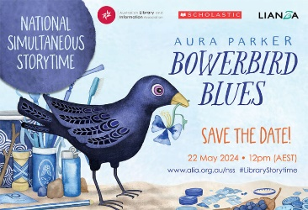 | SRC meeting 8.30am | Pirate Day fundraiser for Cancer Council  Whole School Assembly  Assembly item 2 Garwood  NTLC 10.30am  
Throughout Week 6 | Eisteddfod May 20th-June 2nd  Sorry Day May 26th  Newsletter Front Page: Bec Class items from: Year 5 and 6
Week 7  27 – 31 May | Reconciliation Day  Eco-Rangers meeting- lunchtime   | GOC – National Reconciliation Week event Sadadeen School. full day.  Street Science Incursions- whole school   |  | SRC meeting 8.30am | Interschool Austag
Throughout Week 7 | Eisteddfod May 20th-June 2nd
Week 8  3 – 7 June | Eco-Rangers meeting- lunchtime |  |  | SRC meeting 8.30am | Whole School Assembly  Assembly item 5 Hogan  Interschool Athletics
Throughout Week 8 | Newsletter Front Page: Pip Class items from: Year 3 and 4
Week 9  10 – 14 June | King’s Birthday | School Photos   |  | SRC meeting 8.30am  Whole School Concert  5pm  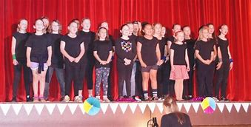 | Interschool Austag Carnival  School Photos
Throughout Week 9 | Crazy Hair Day date TBC Coordinator Kristy and SRC
Week 10  17 – 21 June | NAIDOC Coordinator- Brittany and Auntie Bev  Eco-Rangers meeting- lunchtime | NAIDOC    Buddy Festival | NAIDOC  Alice Beat Cluster rehearsal 11-1pm for Senior Choir    Buddy Festival | NAIDOC  SRC meeting 8.30am  Transition Nursery Rhyme Olympics  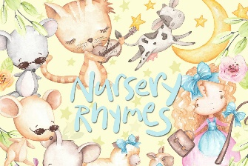 | Last Day of Term 2  Whole School Assembly  PJ Day- Coordinator Kristy and SRC  Assembly item Year 3 classes
Throughout Week 10 | NAIDOC Week July 7th  Buddy Festival- 18-19th June  Newsletter Front Page: Steve and Emma Class items from: Transition

